Project Title:IOT BASED SAFETY GADGET FOR CHILD SAFETY MONITORING AND NOTIFICATION Project Design Phase-I - Solution Fit Team ID: PNT2022TMID23814

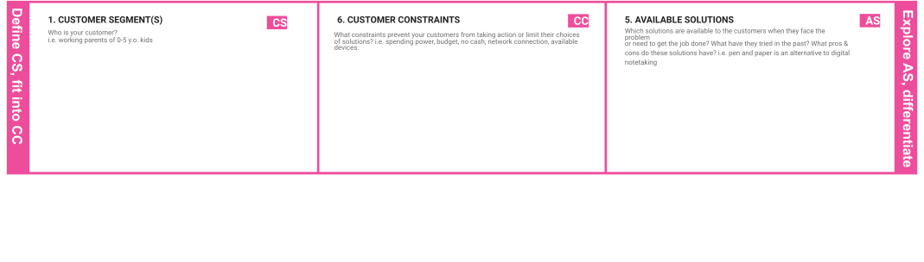

|  |  |  |  |  |
| --- | --- | --- | --- | --- |
|  | **3. TRIGGERS TR**  Panic alert system . | **10. YOUR SOLUTION SL**  The system also consist of Wi Fi module used to implement IOT and send alla the monitor parameters to the cloud for android app monitoring on parental phone panic alert system is used during panic situations alerts are sent to the parental phone ,seeking for help also the alert parameters are updated to the cloud. | 1. **CHANNELS of BEHAVIOUR CH**    1. **the designing of the IOT based child security smart band.it assists parents to monitor their childerenremotely.** |  |
| **4. EMOTIONS: BEFORE / AFTER EM**  Panic alert systems is used during panic situations alerts are sent to the parental phone,seeking for help also the alert parameters are updated to the cloud.. |

|  |  |  |  |  |
| --- | --- | --- | --- | --- |
|  |  |  |  |  |